PROJECT PROPOSAL

NIHVA TECHNOLOGIES PVT. LTD.
187, G-Block, Thermax chowk, Above Renault Showroom, MIDC
Chinchwad, Pune – 411019.

CUSTOMER NAME | ORDNANCE FACTORY DEHUROAD
OFFICE ADDRESS | ORDNANCE FACTORY, DEHU ROAD, MAHARASHTRA 412101
PROJECT LOCATION | ORDNANCE FACTORY DEHUROAD
CONTACT PERSON NAME | MR. T.K PANDA  ENGINEERING HEAD
EMAIL ID | ofdreo.ofb@nic.in
CONTACT NUMBER | +91 9422009885

Contact Person: Mr. Mayur Derle
Mob No.: 7709209333
Web: http://www.nihva.com

AUTOMATION SOLUTION-DIVISION

Contents
A. Requirement 5
B. Scope of work: 5
❖ NIHVA Automation Services Scope of supply: 6
C. Drawings Training and warranty 7
❖ Drawing: 7
❖ Training: 7
❖ Warranty: 7
❖ Maintenance & Service Agreement: 8
D. Details of Application: - 9
❖ NIHVA Machine Operation Sequence: 10
❖ Machine 1 10
❖ Machine 2 10
❖ Machine 3 10
E. Technical Specification: 11
PLC & HMI Make – Siemens / Schneider 11
Motor 1 HP/ 2 HP Make – Sew / Crompton/ Bonfiglioli 11
Bowl Feeder & Linear Feeder, Make – NIHVA 12
Conveyor System Make – ‘NIHVA 12
Proximity Sensors, Make – Sick 13
Pick & Place Machine Make – NIHVA 13
pneumatic cylinder, make – SMC/ FESTO 14
Vision System Make – As suitable 14
Safety features 15
F. Commercial: 16
❖ 16 MM CARTRIDGE ASSEMBLY 16
G. Terms and Conditions: - 17

Ordnance Factory

Title: Automation Of 16 mm Cartridge
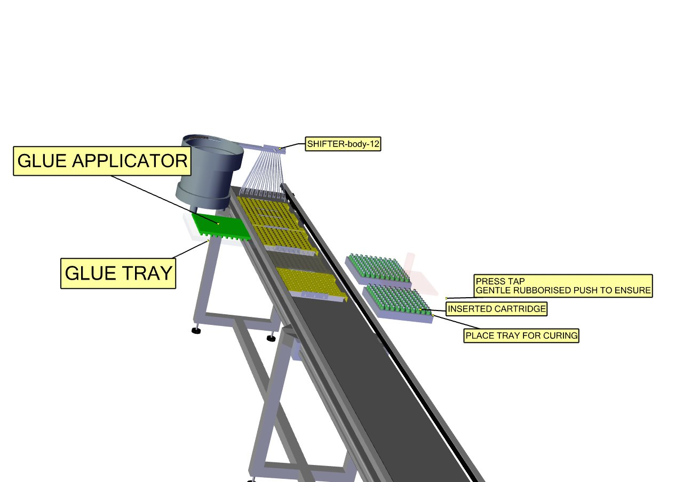

Date: 12.09.2017

To,

Ordnance Factory
Dehuroad, Pune-412101

Kind Attention: Mr. T.K. PANDA

Dear Sir,

Thank you for giving us an opportunity to participate with our offer on the above project. We enclose here with our proposal includes:

- Requirement
- Scope of Works
- Drawing, Training & warranty
- Details of Application
- Technical Specification
- Commercial
- Terms & conditions

Requirement

- Energy efficient Design: The system should be energy efficient. The design shall ensure minimum possible power.

- Reduced Manpower: In this process only few things are done by workers and all the heavy operation will have done by machine automatically. So, this system will require minimum labour work.

Scope of work:
The scope of work shall be exclusively on Automation of 16 mm Cartridge For the above scope,

following set of activities are expected to be performed:

NIHVA Automation Services Scope of supply:

- Design
- Manufacturing
- Successful Trails at our end
- Dispatch at your ends.
- Installation & Commissioning @ ORDNANCE FACTORY DEHURAOD
- Operator & Maintenance Training.
- Warranty of the equipment for 1 year from commissioning date.
- Hard & Soft Copy of Operator & Maintenance Manual.

Drawings Training and warranty

Drawing:

We will issue a full set of shop drawings for approval within 2 weeks of receiving the confirmed order and finalized design details.

Training:

After installation of the automation system, we will train the Clients personnel in the operation and basic maintenance, including the understanding of the error codes on the control system (if applicable).

Warranty:

- The warranty period is twelve months from the date of installation and commissioning.
- If a defect arises within the warranty period stated, which is attributable to faulty design,
- materials or installation workmanship the product will be repaired at our discretion without
- charge. This guarantee is subject to proper use of the product and assumes that the product is
- regularly serviced and maintained by skilled personnel in accordance with the operation and
- maintenance instructions supplied.

Maintenance & Service Agreement:

We would suggest that you take advantage of a maintenance and service agreement on the NIHVA products, which will guarantee trouble free operation and speed of response in an emergency. Customized proposals are available on request.

We are pleased to inform that we also undertake AMC for all of our

products & for any of your existing facilities.

Maintenance and service aren’t about what you get. They’re about what

you avoid: failures, losses and unplanned interruptions.

Details of Application: -

- Components Details
- Work piece Description : 16 mm cartridge
- Weight : 12 gms to 13.43 gms approx.
- Diameter : 16 mm
- Application : Signaling
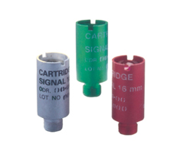

Cartridge signal 16 mm Red/Green/White

NIHVA Machine Operation Sequence:

Machine 1

- In Machine 1 RF Caps will fed to bowl feeder and then passed it linearly through linear feeder each 10 set of caps will pick by picker & tilted it to 90 deg. Drop araldite on it then transfer it to the tray and that filled tray will pass through conveyor. & leave it for 24hrs

Machine 2

- After 24 hrs. the cartridge will exchange manually from one tray to another to make cavity towards upside.
- After that gun powder G40 & G90 will fill to the 100 cartridges at a time.
- After that Star pieces will fed to the bowl feeder and linear feeder and then to tray. By using Visual system, we can make sure the bottom of star should be on upside.
- Then apply APC 217 on star face. After that this tray will inverted into gun powder fed cartridge tray.
- After that Cardboard sheet will passed through bowl Feeder after that apply araldite
On both side of cardboard and then insert it into each cartridge.

Machine 3

- After that index disc will pass through Bowl feeder and place above the cardboard sheet maintaining hill towards upside

Technical Specification:

PLC & HMI Make – Siemens / Schneider

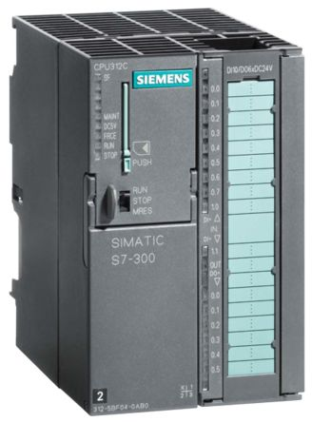

Motor 1 HP/ 2 HP Make – Sew / Crompton/ Bonfiglioli

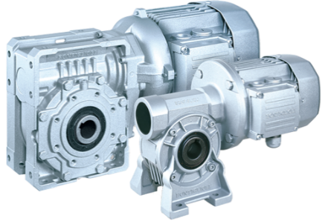

Bowl Feeder & Linear Feeder, Make – NIHVA

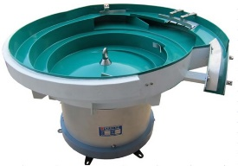

Conveyor System Make – ‘NIHVA

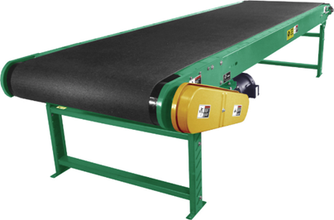

Proximity Sensors, Make – Sick

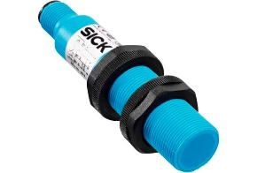

Pick & Place Machine Make – NIHVA

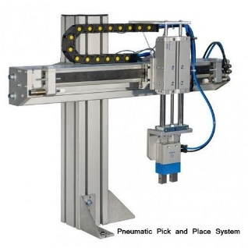

pneumatic cylinder, make – SMC/ FESTO

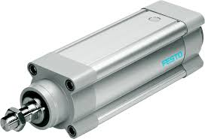

Vision System Make – As suitable

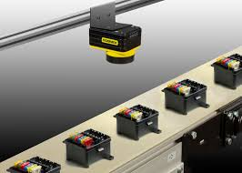

Safety features

- In case of sudden power cut off, system will stand as it is until reset.

- FEA will be conducted for critical elements.

- All units are manufactured considering to work in explosive environment.

- In case of power failure system stop at where they are & resumes on power continuation.

- All vibratory elements are coated with PU Enamel Paint to avoid friction heat.

- Electrical power & signals are transferred through IP 68 rotary enclosure.

- Test Certificate will be provided for whole system.

- Commercial:

- 16 MM CARTRIDGE ASSEMBLY

Sr. No |  | Description |  |  |  | Qty | Price in  INR/Each | Total Amount  In INR
Machine 1  Servo Motor Drive ,Make: Panasonic |  |  |  |  |  | 1 | 26,00,000 | 26,00,000
1. |  | Bowl Feeders |  |  |  | 1 | 26,00,000 | 26,00,000
2. |  | Pick & Place Machine |  |  |  | 1 | 26,00,000 | 26,00,000
3. |  | Outward Assembly |  |  |  | 1 | 26,00,000 | 26,00,000
4. |  | Glue Placer system |  |  |  | 1 | 26,00,000 | 26,00,000
Machine 2
1. |  | Conveyor |  |  |  | 1 | 55,00,000 | 55,00,000
2. |  | Volume Filter assembly |  |  |  | 1 | 55,00,000 | 55,00,000
3. |  | Candle Insertion System |  |  |  | 1 | 55,00,000 | 55,00,000
4. |  | Vision System |  |  |  | 1 | 55,00,000 | 55,00,000
5. |  | Card Board Sheet Placer & Linear Feeder Assembly |  |  |  | 1 | 55,00,000 | 55,00,000
6. |  | Star Placer linear & Glue placer |  |  |  | 1 | 55,00,000 | 55,00,000
7. |  | Plc, Sensors & Control System |  |  |  | 1 | 55,00,000 | 55,00,000
Machine 3
1. |  | Index Disc Placer |  |  |  | 1 | 14,00,000 | 14,00,000
2. |  | Glue Placer Assembly |  |  |  | 1 | 14,00,000 | 14,00,000
3. |  | Installation Charges for Above System |  |  |  | 1 | 15,000 | 15,000
4. |  | Transportation Charges for Above System |  |  |  | 1 | 2,000 | 2,000
 |  | Total Amount |  |  |  |  |  | 95,17,000

G. Terms and Conditions: -

- Price : Ex. Works Pune

- P & F : Included in above prices.

- Freight Notes : Included in above price.

- Delivery : Within 9- 10 weeks from date of receipt of
confirmed purchase order, advance payment, drawing approval.

- Payment Terms : 80% advance along with confirmed purchase
order balance before dispatch.

- Insurance : Extra as applicable.

- GST : 28% Applicable on total supply value.

- Validity : 15 days from date of quotation.

9.Warranty : 12 months from date of supply.

Please feel free to contact Mr. Mayur Derle on 7709209333 for any further clarification in this concern.

With Best Regards,
Pooja Badre
7709209333
NIHVA Technologies Pvt Ltd

